# Report 4: Software Design Description

## Design Overview

This document describes the technical and user interface design of MSSC System. It includes the architectural design, the detailed design of common functions and business functions and the design of database model.

The architectural design describes the overall architecture of the system and the architecture of each main component and subsystem.

The detailed design describes static and dynamic structure for each component and functions. It includes class diagrams, class explanations and sequence diagrams for each use cases.

The database design describes the relationships between entities and details of each entity.

Document overview:

* Section 2: gives an overall description of the system architecture design.
* Section 3: gives component diagrams that describe the connection and integration of the system.
* Section 4: gives the detail design description which includes class diagram, class explanation, and sequence diagram to details the application functions.
* Section 5: overview some main user interface of system.
* Section 6: describe fully attributed ERD.
* Section 7: describe in details all algorithms used in the system.

## System Architectural Design

### Choice of System Architecture

The system is developed using MVC architecture, combine with front end – back end RESTful Web service interface architecture.

## Component Diagram

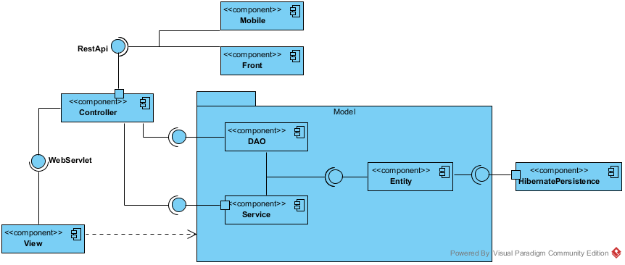

Figure 1: Component Diagram

## Detailed Description Explanation

### Class Diagram

#### Entity Package Class Diagram

Figure 2: Class Diagram

#### Class Diagram Explanation

##### Class 1

Attribute

|  |  |  |  |
| --- | --- | --- | --- |
| **Attribute** | **Type** | **Visibility** | **Description** |
|  |  |  |  |

Method

|  |  |  |  |
| --- | --- | --- | --- |
| **Attribute** | **Type** | **Visibility** | **Description** |
|  |  |  |  |

##### Class 2

Attribute

|  |  |  |  |
| --- | --- | --- | --- |
| **Attribute** | **Type** | **Visibility** | **Description** |
|  |  |  |  |

Method

|  |  |  |  |
| --- | --- | --- | --- |
| **Attribute** | **Type** | **Visibility** | **Description** |
|  |  |  |  |

#### DAO Package Class Diagram

Figure 3: Class Diagram

#### Class Diagram Explanation

##### Class 1

Attribute

|  |  |  |  |
| --- | --- | --- | --- |
| **Attribute** | **Type** | **Visibility** | **Description** |
|  |  |  |  |

Method

|  |  |  |  |
| --- | --- | --- | --- |
| **Attribute** | **Type** | **Visibility** | **Description** |
|  |  |  |  |

##### Class 2

Attribute

|  |  |  |  |
| --- | --- | --- | --- |
| **Attribute** | **Type** | **Visibility** | **Description** |
|  |  |  |  |

Method

|  |  |  |  |
| --- | --- | --- | --- |
| **Attribute** | **Type** | **Visibility** | **Description** |
|  |  |  |  |

#### Service Package Class Diagram

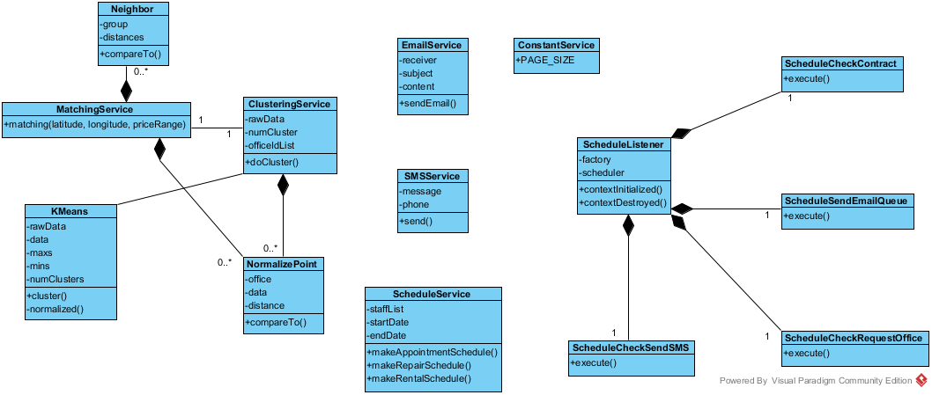

Figure 4: Service Package Class Diagram

#### Class Diagram Explanation

##### EmailService

Attribute

|  |  |  |  |
| --- | --- | --- | --- |
| **Attribute** | **Type** | **Visibility** | **Description** |
| receiver | String | private | The recipient of the email |
| subject | String | private | The subject of the email |
| content | String | private | The content of the email |

Method

|  |  |  |  |
| --- | --- | --- | --- |
| **Attribute** | **Type** | **Visibility** | **Description** |
| sendEmail | boolean | public | Send the email with the subject and content to the receiver |

##### SMSService

Attribute

|  |  |  |  |
| --- | --- | --- | --- |
| **Attribute** | **Type** | **Visibility** | **Description** |
| message | String | private | The SMS message will be sent |
| phone | String | private | The phone number of the recipient |

Method

|  |  |  |  |
| --- | --- | --- | --- |
| **Attribute** | **Type** | **Visibility** | **Description** |
| send() | String | public | Send the SMS message to the recipient. Return “SUCCESS” if sent success, otherwise return the error message form the service provider |

##### ConstantService

Attribute

|  |  |  |  |
| --- | --- | --- | --- |
| **Attribute** | **Type** | **Visibility** | **Description** |
| PAGE_SIZE | int | public | The constant for the page size of the list in admin pages |

##### ScheduleService

Attribute

|  |  |  |  |
| --- | --- | --- | --- |
| **Attribute** | **Type** | **Visibility** | **Description** |
| staffList | List<Staff> | private | The list of all staff for the service |
| startDate | DateTime | private | The start date of the week for the schedule |
| endDate | DateTime | private | The end date of the week for the schedule |

Method

|  |  |  |  |
| --- | --- | --- | --- |
| **Attribute** | **Type** | **Visibility** | **Description** |
| makeAppointmentSchedule() | Map | public | Return the schedule hash map with appointment id and staff username for the unassigned appointment |
| makeRepairSchedule() | Map | public | Return the schedule hash map with repair id and pre-arranged repair for the unassigned repair |
| makeRentalSchedule() | Map | public | Return the schedule hash map with rental id and pre-arranged rental for the unassigned rental |

##### KMeans

Attribute

|  |  |  |  |
| --- | --- | --- | --- |
| **Attribute** | **Type** | **Visibility** | **Description** |
| rawData | double[][] | private | The raw data for k-means algorithm |
| data | double[][] | private | The normalized data for k-means algorithm |
| maxs | double[] | private | The array for max value of each dimension of k-means |
| mins | double[] | private | The array for min value of each dimension of k-means |
| numClusters | int | private | The number of cluster (k) in k-means algorithm |

Method

|  |  |  |  |
| --- | --- | --- | --- |
| **Attribute** | **Type** | **Visibility** | **Description** |
| cluster | double[] | public | Do the k-means algorithm. Return the array of group id for each of input data |
| normalized | double[][] | private | Normalize the raw data |

##### ClusteringService

Attribute

|  |  |  |  |
| --- | --- | --- | --- |
| **Attribute** | **Type** | **Visibility** | **Description** |
| rawData | double[][] | private | The input raw data of all office |
| numCluster | int | private | The calculated k-means number |
| officeIdList | int[] | private | List of all office id |

Method

|  |  |  |  |
| --- | --- | --- | --- |
| **Attribute** | **Type** | **Visibility** | **Description** |
| doCluster | int[] | public | Do the k-means clustering for all office. The result is saved to database also return the array of office group by all office |

##### NormalizePoint

Attribute

|  |  |  |  |
| --- | --- | --- | --- |
| **Attribute** | **Type** | **Visibility** | **Description** |
| office | Office | private | Use to store the office for clustering service |
| data | double[] | private | The normalize data for current office |
| distance | double | private | The distance between the data point and query point in MatchingService |

Method

|  |  |  |  |
| --- | --- | --- | --- |
| **Attribute** | **Type** | **Visibility** | **Description** |
| compareTo() | int | public | Return the compare result of 2 NormalizePoint |

##### MatchingService

Method

|  |  |  |  |
| --- | --- | --- | --- |
| **Attribute** | **Type** | **Visibility** | **Description** |
| matching() | List<Office> | public | Do the matching group for the input office point and the all office data. Return the list of matched office group sort by relevant |

##### Neighbor

Attribute

|  |  |  |  |
| --- | --- | --- | --- |
| **Attribute** | **Type** | **Visibility** | **Description** |
| group | int | private | The index of the office group |
| distances | List<Double> | private | The list of distance of query point and office in group for the KNN matching service |

Method

|  |  |  |  |
| --- | --- | --- | --- |
| **Attribute** | **Type** | **Visibility** | **Description** |
| compareTo() | int | public | Compare distance between query point and two list of data |

##### ScheduleListener

Attribute

|  |  |  |  |
| --- | --- | --- | --- |
| **Attribute** | **Type** | **Visibility** | **Description** |
| factory | SchedulerFactory | private | The factory for initiate the scheduler |
| scheduler | Scheduler | private | The class contain the instance of the scheduler factory |

Method

|  |  |  |  |
| --- | --- | --- | --- |
| **Attribute** | **Type** | **Visibility** | **Description** |
| contextInitialized() | void | public | Override context listener when the app initialized |
| contextDestroyed() | void | public | O Override context listener when the app destroyed |

##### ScheduleCheckContract

Method

|  |  |  |  |
| --- | --- | --- | --- |
| **Attribute** | **Type** | **Visibility** | **Description** |
| execute | void | public | Execute the schedule for check the contract due date. Cancel the contract if the contract at due date |

##### ScheduleCheckRequestOffice

Method

|  |  |  |  |
| --- | --- | --- | --- |
| **Attribute** | **Type** | **Visibility** | **Description** |
| execute | void | public | Execute the schedule for check the Request office. Stored the found office and queue to send an email to customer |

##### ScheduleCheckSendSMS

Method

|  |  |  |  |
| --- | --- | --- | --- |
| **Attribute** | **Type** | **Visibility** | **Description** |
| execute | void | public | Execute the schedule for check the appointment date. Send a SMS to user if the appointment date is near |

##### ScheduleCheckEmailQueue

Method

|  |  |  |  |
| --- | --- | --- | --- |
| **Attribute** | **Type** | **Visibility** | **Description** |
| execute | void | public | Execute the schedule for check the email in queue to send |

#### Controller Package Class Diagram

Figure 5: Class Diagram

#### Class Diagram Explanation

##### Class 1

Attribute

|  |  |  |  |
| --- | --- | --- | --- |
| **Attribute** | **Type** | **Visibility** | **Description** |
|  |  |  |  |

Method

|  |  |  |  |
| --- | --- | --- | --- |
| **Attribute** | **Type** | **Visibility** | **Description** |
|  |  |  |  |

##### Class 2

Attribute

|  |  |  |  |
| --- | --- | --- | --- |
| **Attribute** | **Type** | **Visibility** | **Description** |
|  |  |  |  |

Method

|  |  |  |  |
| --- | --- | --- | --- |
| **Attribute** | **Type** | **Visibility** | **Description** |
|  |  |  |  |

#### View Package Class Diagram

Figure 6: Class Diagram

#### Class Diagram Explanation

##### Class 1

Attribute

|  |  |  |  |
| --- | --- | --- | --- |
| **Attribute** | **Type** | **Visibility** | **Description** |
|  |  |  |  |

Method

|  |  |  |  |
| --- | --- | --- | --- |
| **Attribute** | **Type** | **Visibility** | **Description** |
|  |  |  |  |

##### Class 2

Attribute

|  |  |  |  |
| --- | --- | --- | --- |
| **Attribute** | **Type** | **Visibility** | **Description** |
|  |  |  |  |

Method

|  |  |  |  |
| --- | --- | --- | --- |
| **Attribute** | **Type** | **Visibility** | **Description** |
|  |  |  |  |

#### Front Package Class Diagram

Figure 7: Class Diagram

#### Class Diagram Explanation

##### Class 1

Attribute

|  |  |  |  |
| --- | --- | --- | --- |
| **Attribute** | **Type** | **Visibility** | **Description** |
|  |  |  |  |

Method

|  |  |  |  |
| --- | --- | --- | --- |
| **Attribute** | **Type** | **Visibility** | **Description** |
|  |  |  |  |

##### Class 2

Attribute

|  |  |  |  |
| --- | --- | --- | --- |
| **Attribute** | **Type** | **Visibility** | **Description** |
|  |  |  |  |

Method

|  |  |  |  |
| --- | --- | --- | --- |
| **Attribute** | **Type** | **Visibility** | **Description** |
|  |  |  |  |

#### Mobile Package Class Diagram

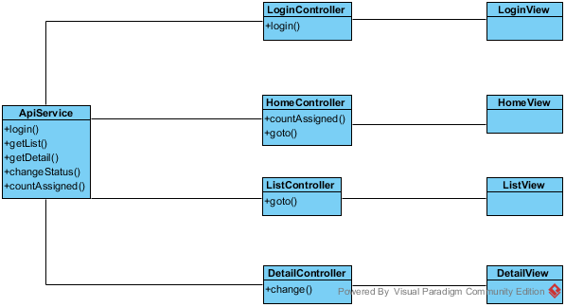

Figure 8: Mobile Package Class Diagram

#### Class Diagram Explanation

##### ApiService

Method

|  |  |  |  |
| --- | --- | --- | --- |
| **Attribute** | **Type** | **Visibility** | **Description** |
| login() | function | public | Call the login api and return the result. |
| getList() | function | public | Call the getList api to return the list of job for current staff (appointment/rental/repair) |
| getDetail() | function | public | Call the getDetail api to return the detail of current job |
| countAssigned() | function | public | Call the countAssigned api to return the number of assigned for current job |
| changeStatus() | function | public | Call the changeStatus api to change the status of current job |

##### LoginController

Attribute

|  |  |  |  |
| --- | --- | --- | --- |
| **Attribute** | **Type** | **Visibility** | **Description** |
| username | string | private | The inputted username |
| password | string | private | The inputted password |

Method

|  |  |  |  |
| --- | --- | --- | --- |
| **Attribute** | **Type** | **Visibility** | **Description** |
| login() | function | private | Call the login function of ApiService |

##### LoginView

This is the presentation view of LoginController

##### HomeController

Attribute

|  |  |  |  |
| --- | --- | --- | --- |
| **Attribute** | **Type** | **Visibility** | **Description** |
| title | string | private | The title of the job (appointment/rental/repair) |
| badge | Array | private | The array of number of assigned job |

Method

|  |  |  |  |
| --- | --- | --- | --- |
| **Attribute** | **Type** | **Visibility** | **Description** |
| countAssigned() | function | private | Call the countAssigned function of ApiService to get the job number |
| goto() | function | private | Go to the list page of the job |

##### HomeView

This is the presentation view of HomeController

##### ListController

Attribute

|  |  |  |  |
| --- | --- | --- | --- |
| **Attribute** | **Type** | **Visibility** | **Description** |
| title | string | private | The title of the job (appointment/rental/repair) |
| data | Array | private | The array of the detail of job |

Method

|  |  |  |  |
| --- | --- | --- | --- |
| **Attribute** | **Type** | **Visibility** | **Description** |
| goto() | function | private | Go to the detail page of the job |

##### ListView

This is the presentation view of ListController

##### DetailController

Attribute

|  |  |  |  |
| --- | --- | --- | --- |
| **Attribute** | **Type** | **Visibility** | **Description** |
| title | string | private | The title of the job (appointment/rental/repair) |
| data | object | private | The detail of job |

Method

|  |  |  |  |
| --- | --- | --- | --- |
| **Attribute** | **Type** | **Visibility** | **Description** |
| change() | function | private | Call the api to change the status of the job |

##### DetailView

This is the presentation view of DetailController

### Interaction Diagram

#### <Staff> Create office

**Summary:** This diagram used to describe the process of staff create an office

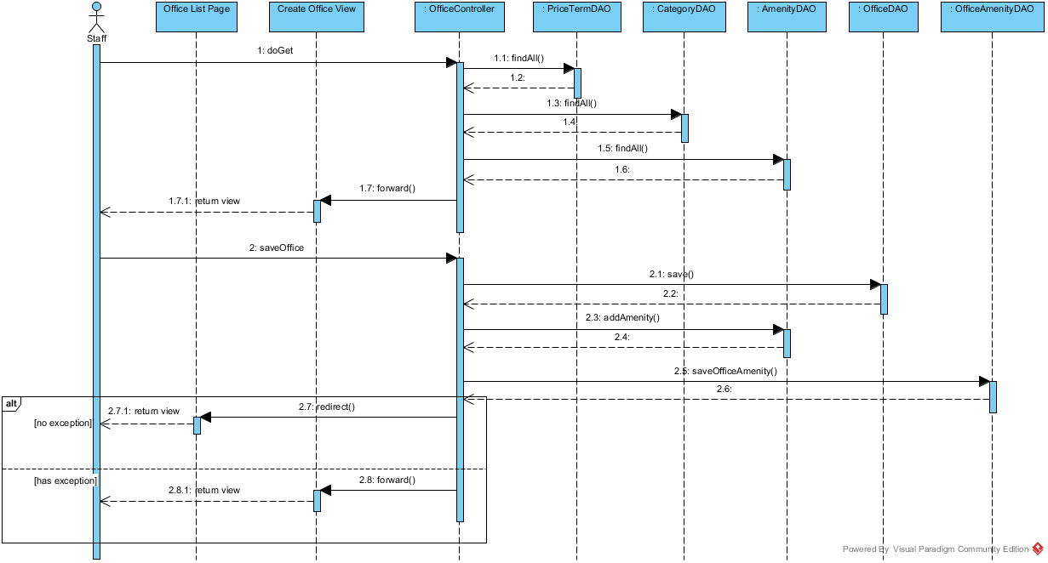

Figure 10: Create office Sequence Diagram

#### <Manager> Create contract

**Summary:** This diagram used to describe the process of create new contract.

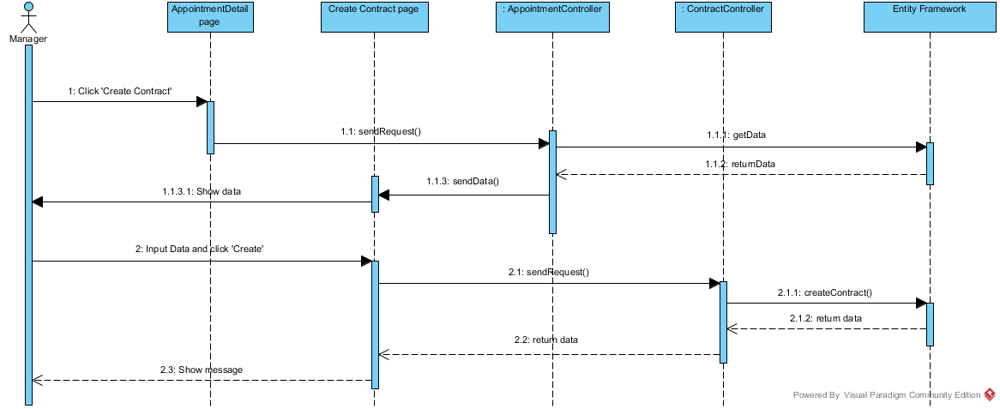

Figure 11: Create Contract Sequence Diagram

#### <Manager> Assign Appointment

**Summary:** This diagram used to describe the process of manager assign an appointment to a staff

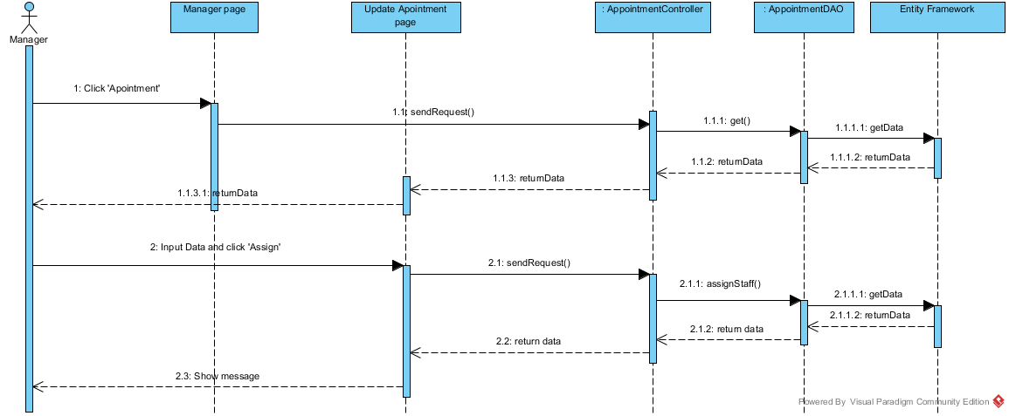

Figure 12: Assign Appointment Sequence Diagram

#### <Manager> Update Appointment

**Summary:** This diagram used to describe the process of manager update an appointment detail

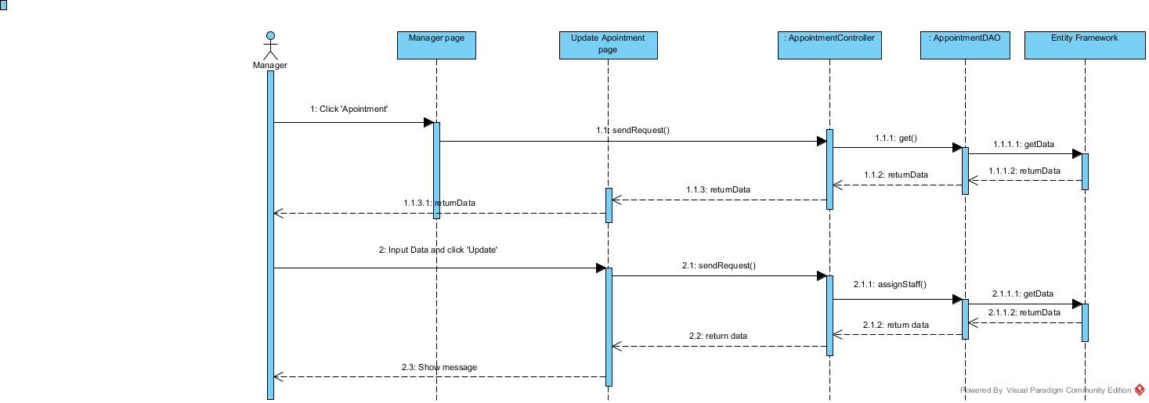

Figure 13: Update Appointment Sequence Diagram

#### <Customer> Get Office List

**Summary:** This diagram used to describe the process of customer request repair office

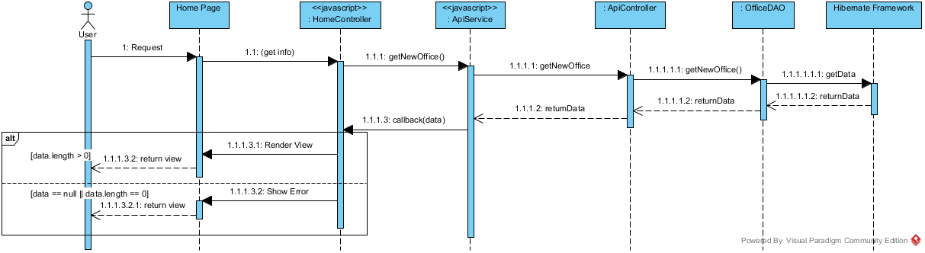

Figure 14: Get office list Sequence Diagram

#### <Customer> Request Appointment

**Summary:** This diagram used to describe the process of customer request an appointment.

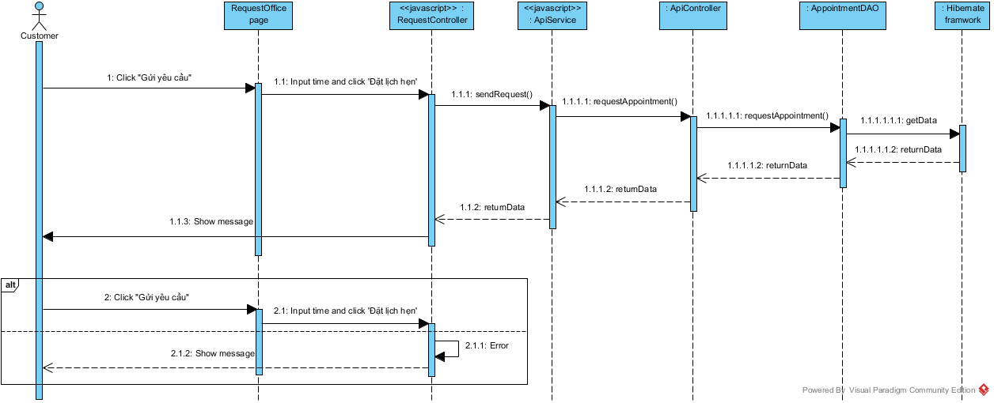

Figure 15: Request Appointment Sequence Diagram

#### <Customer> Request Repair

**Summary:** This diagram used to describe the process of customer request repair office

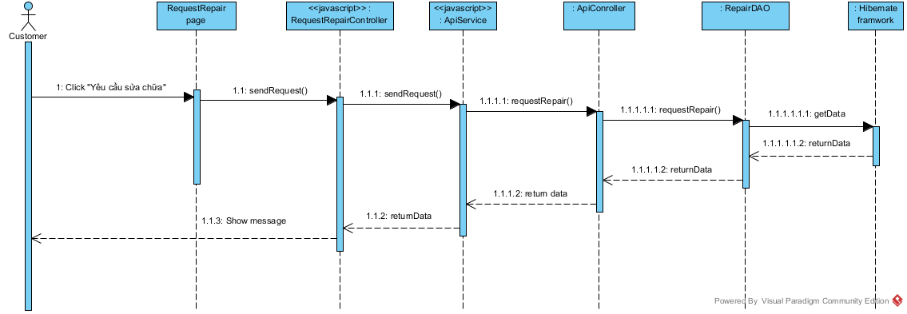

Figure 16: Request Repair Sequence Diagram

#### <Admin> Ban Account

**Summary:** This diagram used to describe the process of admin ban an account.

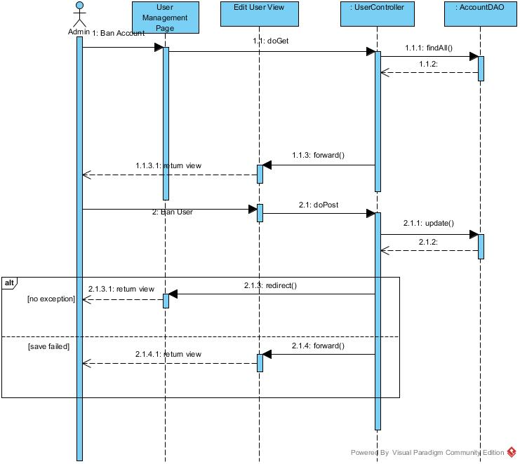

Figure 17 : Ban Account Sequence Diagram

#### < Manager> Cancel Request

**Summary:** This diagram used to describe the process of manager cancel request.

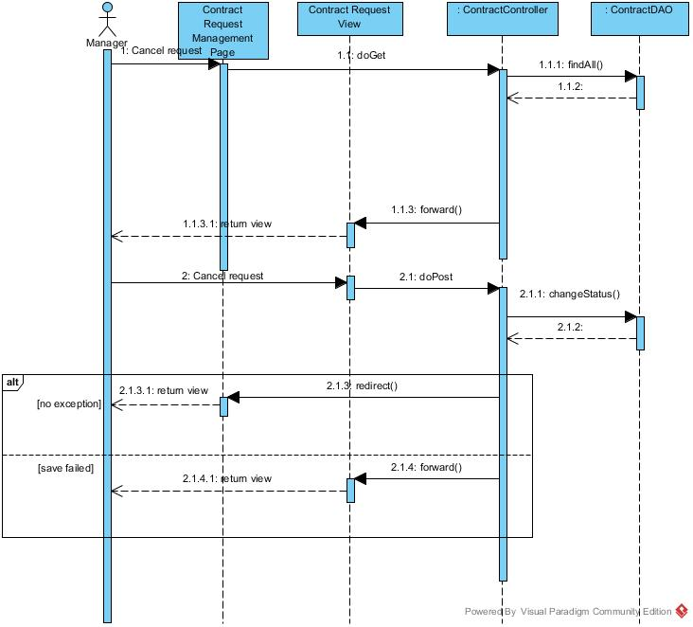

Figure 18 :<Manager> Cancel Request Sequence Diagram

#### < Admin> Create Account

**Summary:** This diagram used to describe the process of admin creates account.

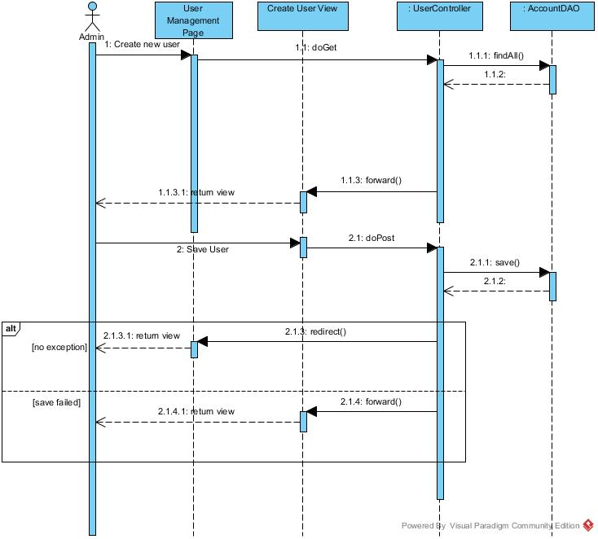

Figure 19 : <Admin> Create Account Sequence Diagram

#### < Manager, Staff> Create Amenity Sequence Diagram

**Summary:** This diagram used to describe the process of manager or staff creates amenity.

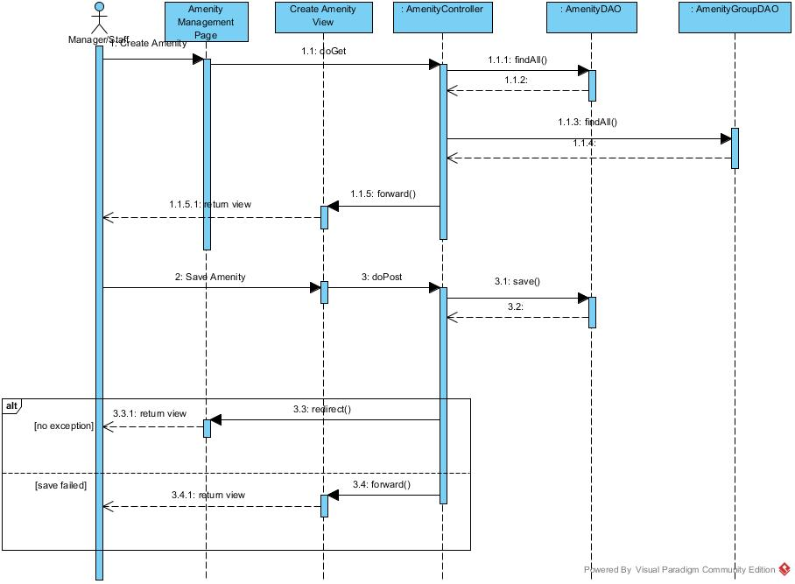

Figure 20 : <Manager, Staff> Create Amenity Sequence Diagram

#### < Manager> Create Amenity Group

**Summary:** This diagram used to describe the process of manager creates amenity group.

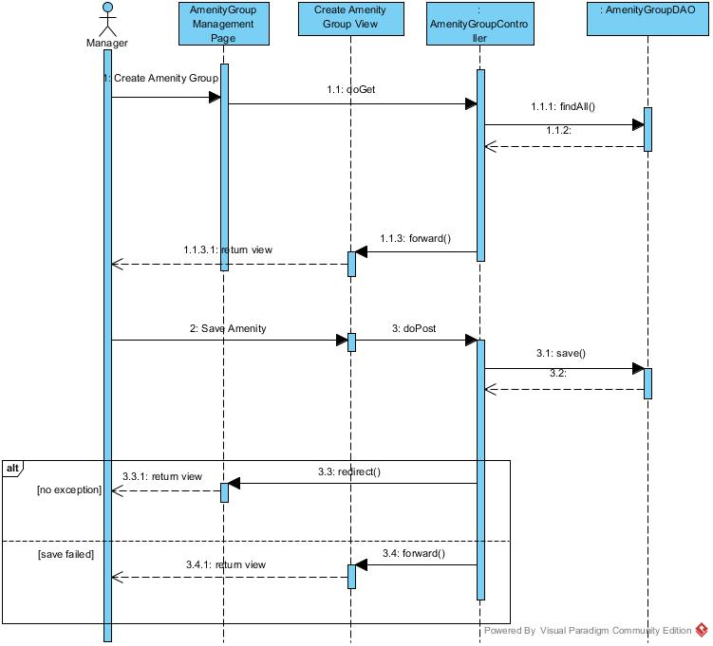

Figure 21 : <Manager> Create Amenity Group Sequence Diagram

#### < Staff> Create New Office

**Summary:** This diagram used to describe the process of staff create new office.

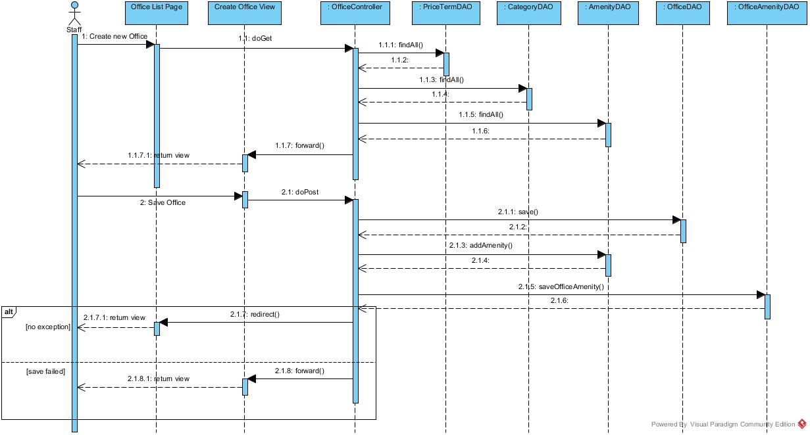

Figure 22 :<Staff> Create New Office Sequence Diagram

#### < Manager> Change Repair Status

**Summary:** This diagram used to describe the process of manager change repair status.

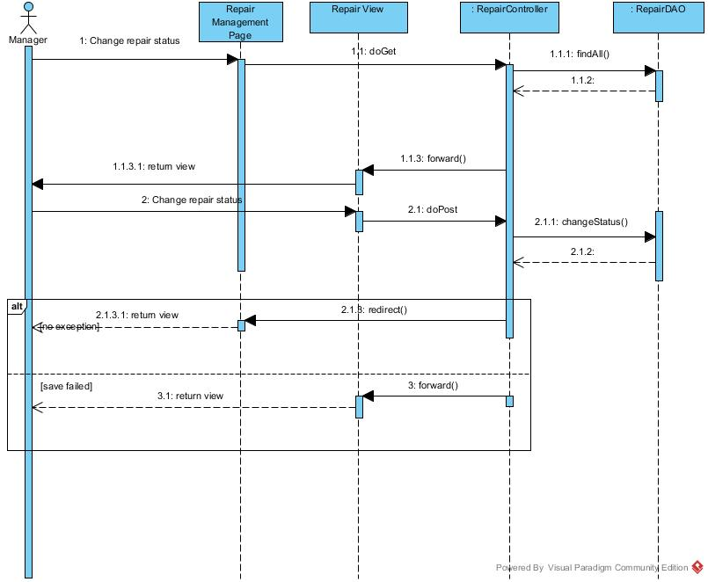

Figure 23 : <Manager>Change Repair Status Sequence Diagram

#### < Manager> Delete Amenity

**Summary:** This diagram used to describe the process of manager delete amenity.

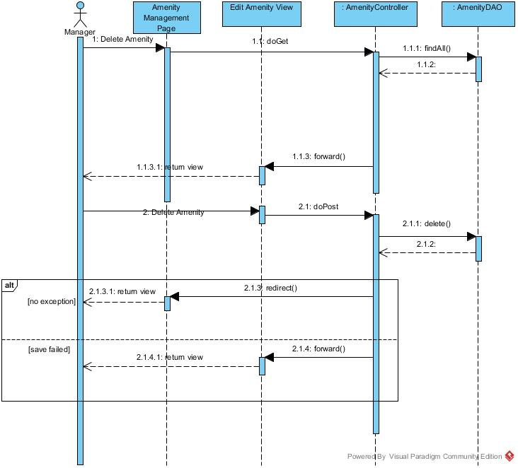

Figure 24 :<Manager> Delete Amenity Sequence Diagram

#### < Manager> Delete Return Contract

**Summary:** This diagram used to describe the process of manager delete return contract

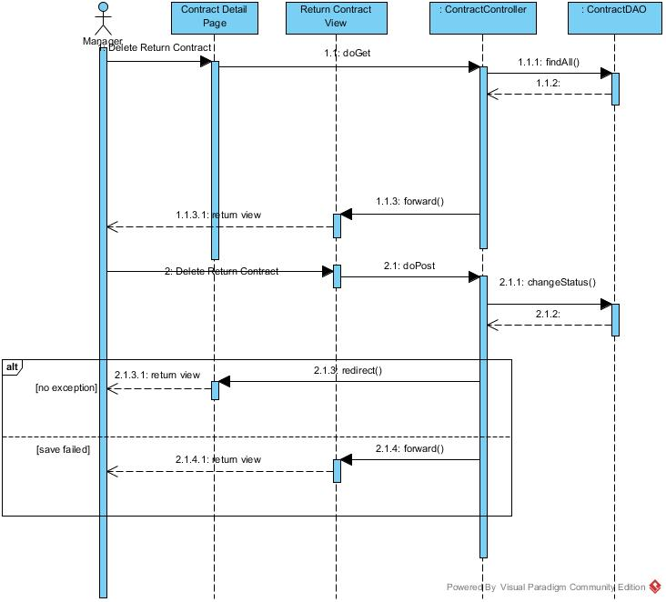

Figure 25 : <Manager> Delete Return Contract Sequence Diagram

#### < Admin> Delete User

**Summary:** This diagram used to describe the process of manager delete account user.

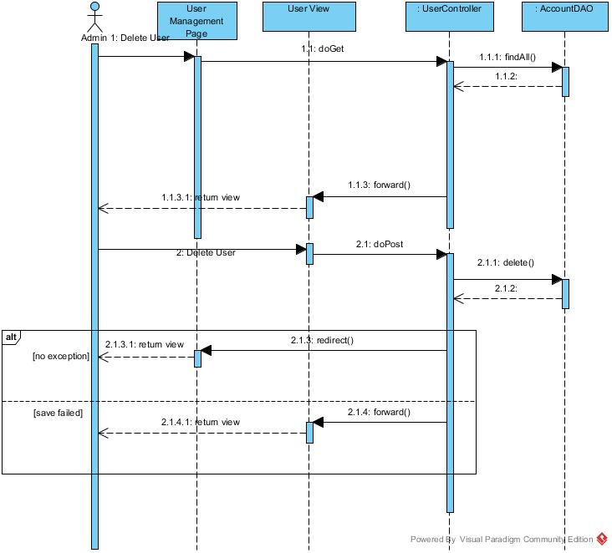

Figure 26 :<Admin> Delete User Sequence Diagram

#### < Admin> Edit User

**Summary:** This diagram used to describe the process of manager edit user

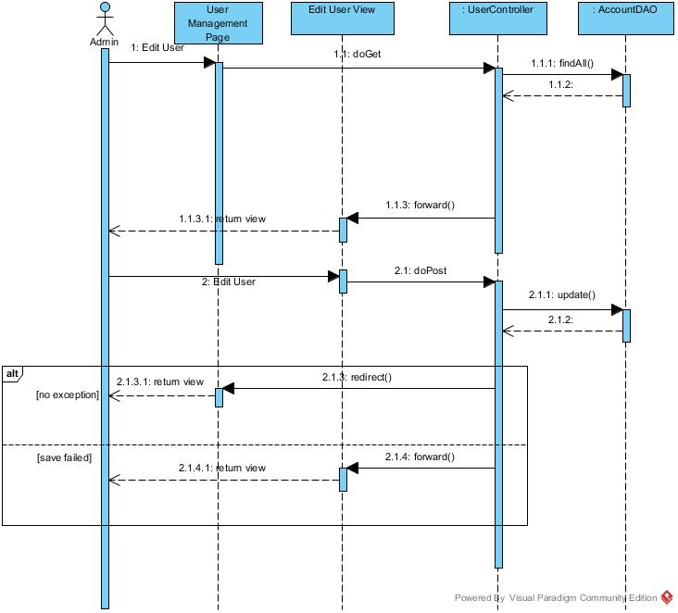

Figure 27 :<Admin> Edit User Sequence Diagram

#### < Manager> Edit Amenity

**Summary:** This diagram used to describe the process of manager edit amenity.

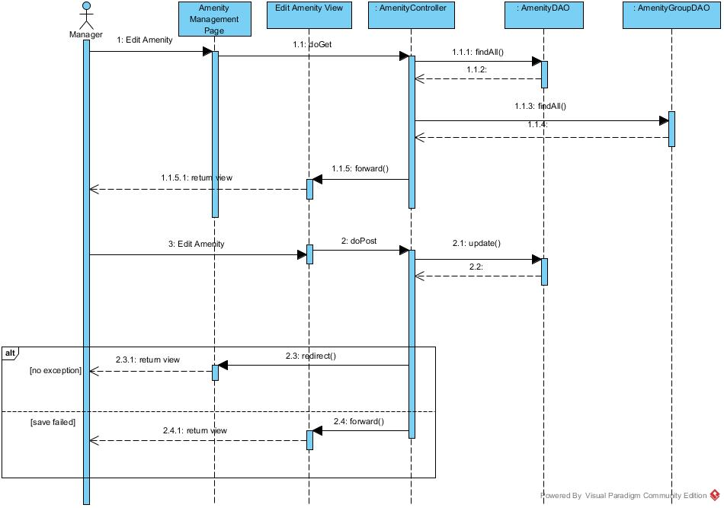

Figure 28 :<Manager> Edit Amenity Sequence Diagram

#### < Manager> Edit Amenity Group

**Summary:** This diagram used to describe the process of manager edit amenity group

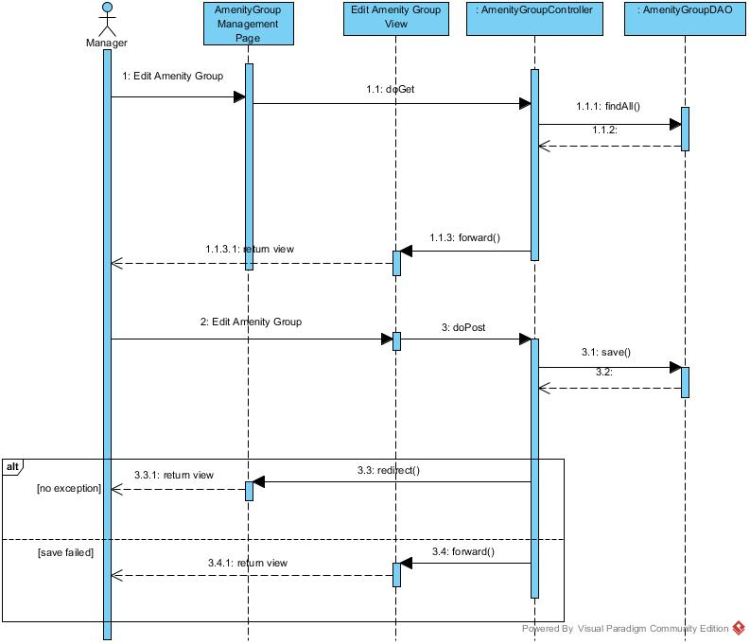

Figure 29 :<Manager>Edit Amenity Group Sequence Diagram

#### < Manager> Edit Contract

**Summary:** This diagram used to describe the process of manager edit contract.

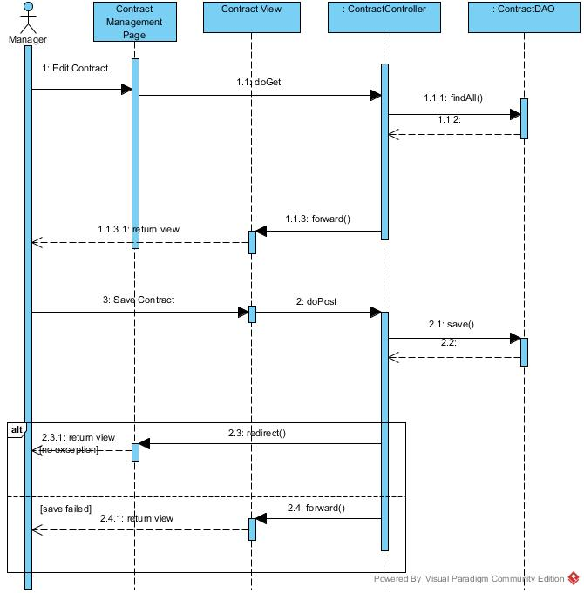

Figure 30 :<Manager> Edit Contract Sequence Diagram

#### < Manager> Edit Extend Contract

**Summary:** This diagram used to describe the process of manager edit extend contract

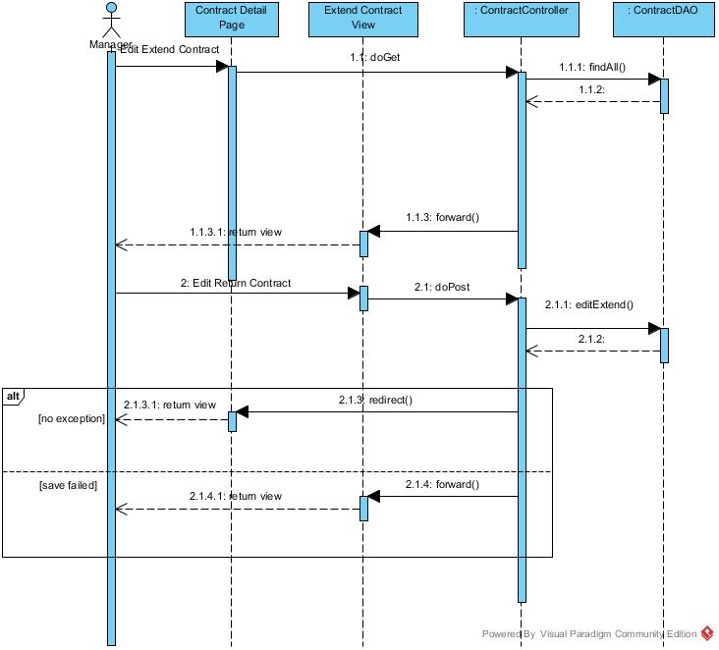

Figure 31 :<Manager>Edit Extend Contract Sequence Diagram

#### < Admin> Unban Account

**Summary:** This diagram used to describe the process of admin unbans account.

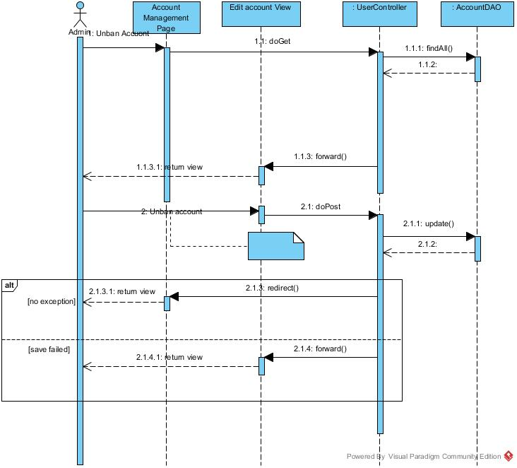

Figure 32 :<Admin> Unban Account Sequence Diagram

#### < Admin> View Account List

**Summary:** This diagram used to describe the process admin view account list.

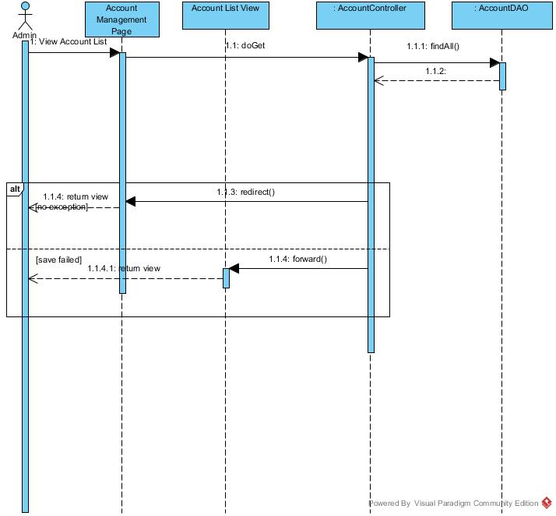

Figure 33 :<Admin> View Account List Sequence Diagram

#### < Manager> View Amenity Group List

**Summary:** This diagram used to describe the process of manager view amenity group list.

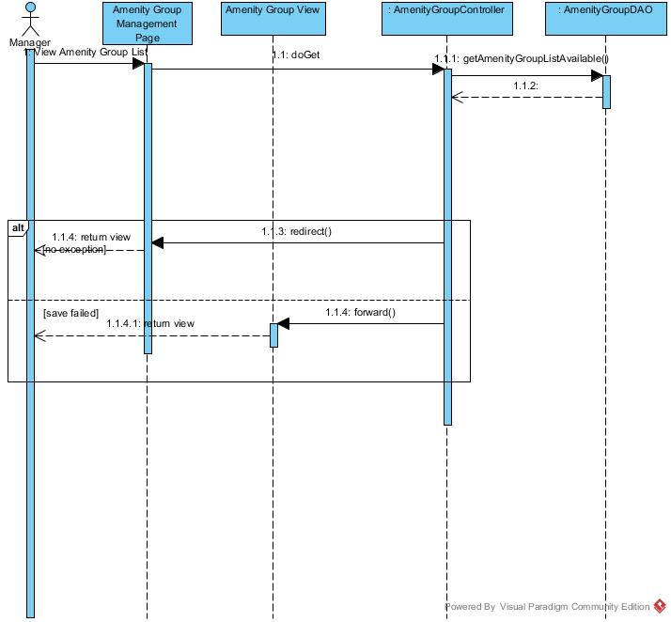

Figure 34 :<Manager> View Amenity Group List Sequence Diagram

#### < Manager> View Amenity List

**Summary:** This diagram used to describe the process of manager view amenity list

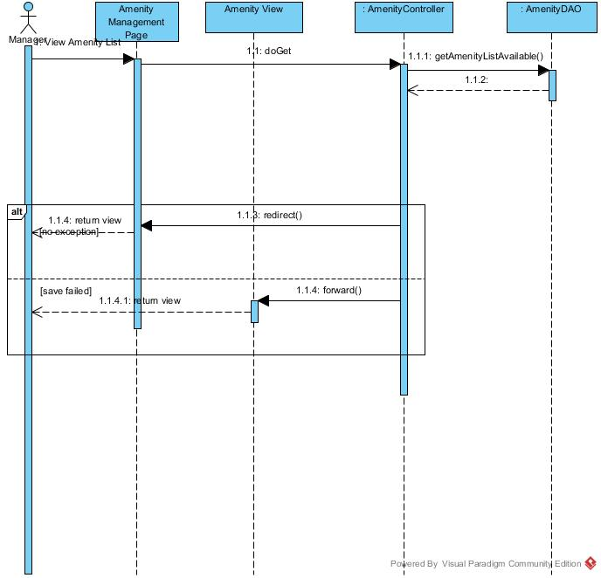

Figure 35 :<Manager> View Amenity List Sequence Diagram

#### < Staff> View Assigned Repair Request

**Summary:** This diagram used to describe the process of staff view assigned repair request.

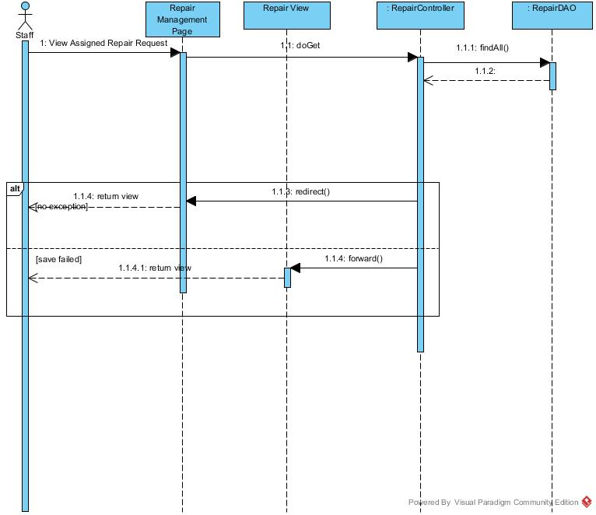

Figure 36 :<Staff> View Assigned Repair Request Sequence Diagram

#### < Manager> View Contract List

**Summary:** This diagram used to describe the process of manager view contract list.

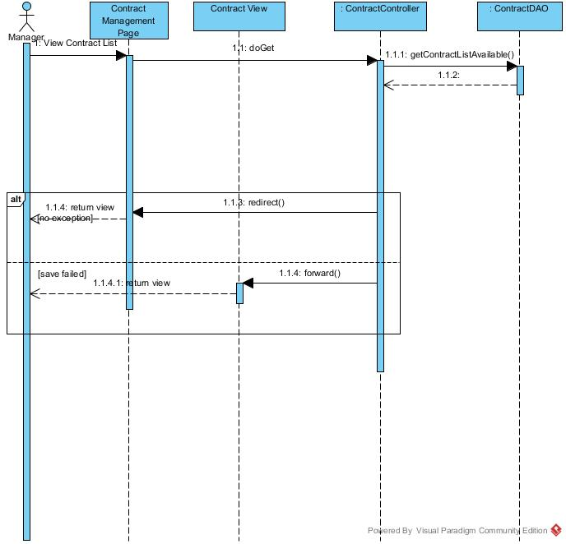

Figure 37 :<Manager> View Contract List Sequence Diagram

#### < Manager> View Request Extend List

**Summary:** This diagram used to describe the process of view request extend list.

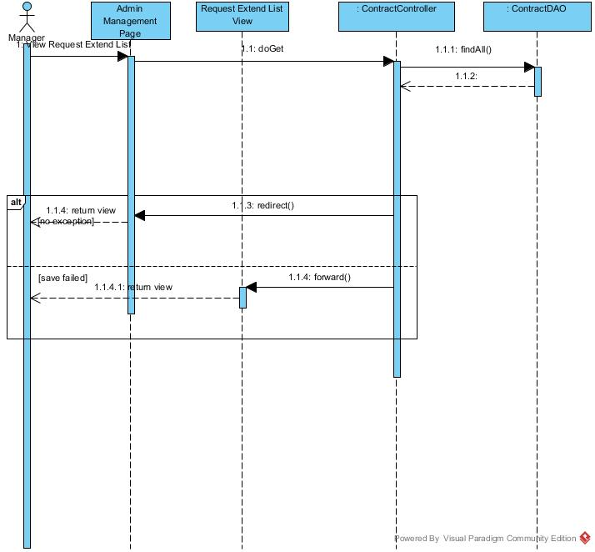

Figure 38 :<Manager> View Request Extend List Sequence Diagram

#### < Manager> View Request Return Contract

**Summary:** This diagram used to describe the process of manager view request return contract

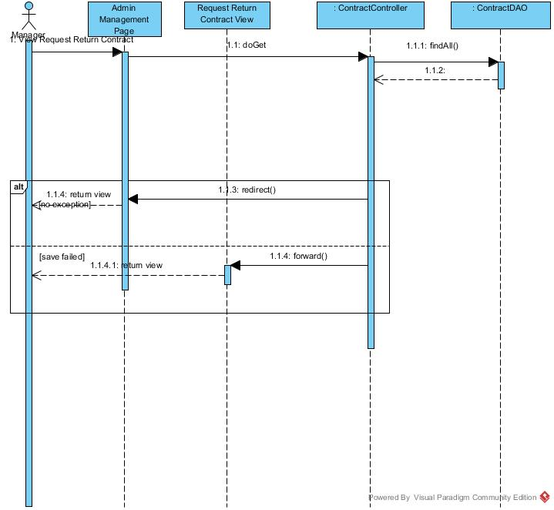

Figure 39 : <Manager> View Request Return Contract Sequence Diagram

## User Interface Design

### Guest Interface Design

## Database Design

### Logical Diagram

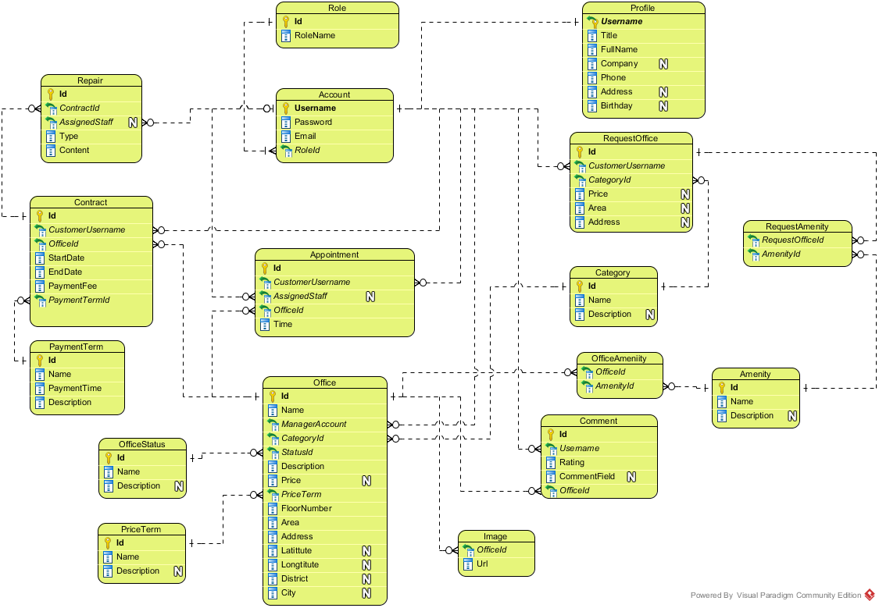

**Figure 17: Logical Database Diagram**

### Data Dictionary

|  |  |
| --- | --- |
| **Entity Data dictionary: describe content of all entities** | |
| **Entity Name** | **Description** |
| Account | Describe account of user of system. |
| Staff | Describe account type staff |
| Admin | Describe account type admin |
| Manager | Describe account type manager |
| Customer | Describe account type customer |
| Profile | Describe the contact information for customer |
| Office | Describe information of the office |
| Category | Describe the category of the office |
| Amenity | Describe the amenities of the office |
| Image | List of images of the office |
| Appointment | Describe the information of the appointment of customer for the office |
| Contract | Describe the information of contract between customer and office |
| Request Office | Describe the stored office request of customer |
| Repair | Describe the repair request for each contract |
| Rental | Describe the rental request for contract |
| Rental Item | Describe the rental items which available for rental request |
| Account | Describe account of user of system. |
| Staff | Describe account type staff |
| Admin | Describe account type admin |
| Manager | Describe account type manager |
| Customer | Describe account type customer |

Table 1: Entity Data Dictionary

## Algorithms

### Clustering data

#### Definition

Given the offices which have different location and price range. Place those offices into different groups that have similarity

#### Define Problem

* Office in near location may have similarity in price range. But the location may vary and hard to define all location.
* Group the office by location and price range will make the user easier to find the similarity offices

#### Solution

To solve the problem, we use the well-known K-Means algorithm.

The step to perform the algorithm:

1. Defined the k number (number of cluster)
   * The k number is calculate by the square root of total of data (n). This make sure that there is $\sqrt{n}$ group, and each group has about $\sqrt{n}$ data
2. Normalize the data into the n-dimensions Euclidean space, all data based on [0, 1] distance. Each of office data is called “point”
   * In this problem, we use 3 statics: latitude, longitude and price range of the office for 3-dimensions
   * The price range is divided into 5 range: Call as 0, 100.000 VND – 200.000 VND as 1, etc., larger than 500.000 VND as 5
   * In each dimension, calculate the min and max. Then the normalize dimension data is calculate by:

$$\text{normalized}=\frac{data-min}{max-min}$$

normalize: dimension normalized data

data: the raw data in dimension

1. Select random point into k group, each group has at least 1 point
2. Calculate the mean points of each group
3. Calculate the distance of each data point to each group’s mean point, and change the group of data point to the group that has the nearest mean
   * The distance between A(a1, a2, … an) and X(x1, x2, … xn) is calculate by Euclidean distance:

$$d=\sqrt{{\left(a_{1}-x_{1}\right)}^{2}+{\left(a_{2}-b_{2}\right)}^{2}+…+{\left(a_{n}-b_{n}\right)}^{2}}$$

Where n is the number of dimension

1. Repeat step 4 until the group in step 5 is unchanged

#### Complexity

* In total, the complexity of this algorithm is NP-hard. But with current algorithm maximum complexity limit to n*10 (n is total of data)

#### Flow chart

Calculate K

Normalize data

Group data in K groups

Calculate the mean of each group

Group based on minimum distance to mean

Group changed?

End

Start

Yes

No

### Matching data

#### Definition

Given the search office criteria, take out the result group (as calculate above) that have the most similarity with the criteria.

#### Define Problem

* The search office may be different from all of the office in system, and user want to make their decision with vary of result.

#### Solution

With the clustering data using K-Means, the best solution is KNN (K-Nearest-Neighbor) algorithm.

The steps to perform the algorithm:

1. Define k number. In this solution, we choose k at least by haft of the average office in each group of K-Means algorithm. Particular 2 $\sqrt{n}$* .
2. Normalize the query point (input data) to the same dimension of sample data (by above function)
3. Calculate the distance between query point and each of data in sample (all office) by Euclidean distance (as above).
4. Sort the calculated distance, select the minimum k distances for comparison.
5. The group of query point will be group that have the most frequent existence in above k distances. If there is more than 1 group that have largest existence, the selected group will be the group that have minimum total distance (in the k selected distances only)

#### Complexity

* In total, the complexity of this algorithm is O(n)

#### Flow chart

Calculate K

Normalize query point (Y)

Calculate distance Y -> Xn

Select k nearest distance above

Group based on minimum distance to mean

Group number > 2?

Start

Select the group that have most existence

Select group that have minimum total distance

End

No

Yes